**A**

**Project Report**

on

“Implementation of a boolean function using 8:1 MULTIPLEXER”

**Submitted by**

by

#### Sumeet P Bafna (USN: 2GI19CS157)

#### Venkatesh Dhongadi (USN: 2GI19CS175)

#### Vivek Jadhav (USN: 2GI19CS185)

#### Vivek Valagadde (USN: 2GI19CS186)



Department of Digital Electronics

KLS Gogte Institute of Technology,

Udyambag, Belgaum - 590008, Karnataka, India

**THEORY:**

* Multiplexer is a combinational circuit that is one of the most widely used in digital design.
* The multiplexer is a data selector which gates one out of several inputs to a single o/p. It has n data inputs & one o/p line & m select lines where 2m= n shown in fig a.
* Depending upon the digital code applied at the select inputs one out of n data input is selected & transmitted to a single o/p channel.
* Normally strobe (G) input is incorporated which is generally active low which enables the multiplexer when it is LOW. Strobe i/p helps in cascading.
* IC 74151A is an 8: 1 multiplexer which provides two complementary outputs Y & Y. The o/p Y is same as the selected i/p & Y is its complement. The n: 1 multiplexer can be used to realize a m variable function. (2m= n, m is no. of select inputs)

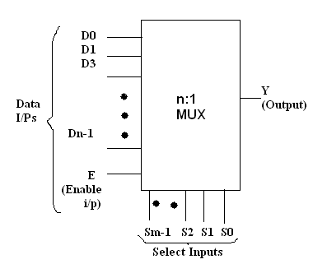

***Fig. a Block diagram of n:1 MUX***

**Necessity of multiplexers:**

* In most of the electronic systems, the digital data is available on more than one line. It is necessary to route this data over a single line.
* Under such circumstances we require a circuit which selects one of the many inputs at a time.
* This circuit is nothing else but a multiplexer, which has many inputs, one output & some select inputs.
* Multiplexer improves the reliability of the digital system because it reduces the number of external wired connections.

**Types of MUX:**

1. 2:1 MUX 2. 4:1 MUX 3) 8:1 MUX

4. 16:1 MUX 5. 32:1 MUX

**8:1 Multiplexer:**

It has eight data inputs D0 to D7, three select inputs S0 to S2, an enable input and one output.

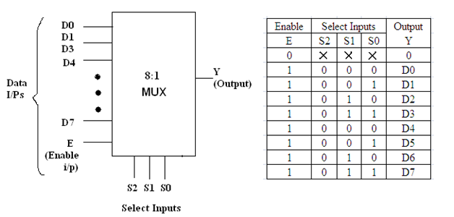

***Fig. Block diagram of n: 1 MUX Fig. Truth Table of 8:1 MUX***

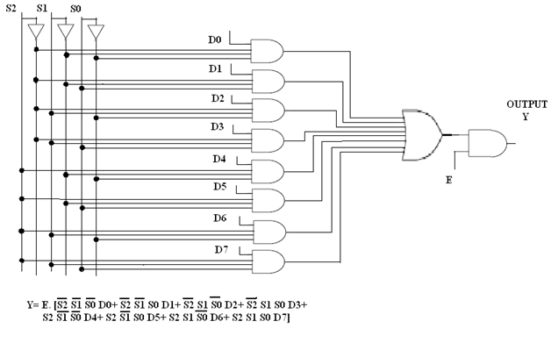

**Problem Statement:**

Implementation of 4-variable Boolean Function using 8:1 Multiplexer by using IC 74LS151(8:1 Mux). F (A, B, C, D) =Σm(0,2,5,6,7,8,11,12,14,15)

**Solution:**

Taking *A* as MEV

|  |  |  |  |  |  |  |  |  |
| --- | --- | --- | --- | --- | --- | --- | --- | --- |
|  | **D0** | **D1** | **D2** | **D3** | **D4** | **D5** | **D6** | **D7** |
| **A=0** | **0** | **1** | **2** | **3** | **4** | **5** | **6** | **7** |
| **A=1** | **8** | **9** | **10** | **11** | **12** | **13** | **14** | **15** |
|  | **1** | **0** | **A̅** | **A** | **A** | **A̅** | **1** | **1** |

**Diagram of multiplexer:**

D0

D1

D2

D3

D4

D5

D6

D7

+5v

ground

A’ Y = OUTPUT

A

A

A’

+5v

+5v

B C D

**Truth table for the given sum:**

|  |  |  |  |  |
| --- | --- | --- | --- | --- |
| **A** | **B** | **C** | **D** | **Output** |
| **0** | **0** | **0** | **0** | **1** |
| **0** | **0** | **0** | **1** | **0** |
| **0** | **0** | **1** | **0** | **1** |
| **0** | **0** | **1** | **1** | **0** |
| **0** | **1** | **0** | **0** | **0** |
| **0** | **1** | **0** | **1** | **1** |
| **0** | **1** | **1** | **0** | **1** |
| **0** | **1** | **1** | **1** | **1** |
| **1** | **0** | **0** | **0** | **1** |
| **1** | **0** | **0** | **1** | **0** |
| **1** | **0** | **1** | **0** | **0** |
| **1** | **0** | **1** | **1** | **1** |
| **1** | **1** | **0** | **0** | **1** |
| **1** | **1** | **0** | **1** | **0** |
| **1** | **1** | **1** | **0** | **1** |
| **1** | **1** | **1** | **1** | **1** |

**REALIZATION:**

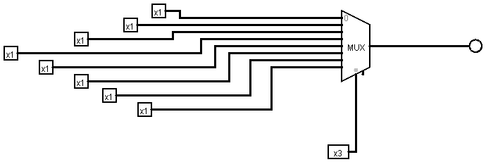

**LOGIC DIAGRAM:**

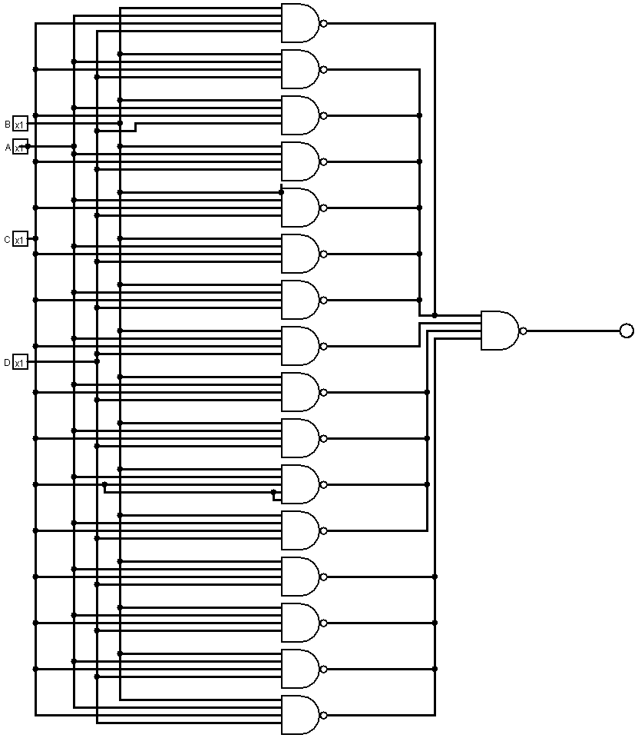

**Conclusion:**

SOP expression can be successfully implemented by 8 : 1 multiplexer as show above by taking any one of the variable as map entered variable (MEV) .Multiplexer can also be demonstrated successfully by designing a logic circuit as show above and also the output can be verified for different input combinations

**References:**

* Donald P Leach, Albert Paul Malvino and Goutam Saha: Digital Principles and Applications, 7th Edition and onwards, Tata McGraw Hill, 2011.
* <https://www.google.co.in/>